Lab5: Key-Value Store [Solutions]

Table1. Course Information

|  |  |  |  |  |
| --- | --- | --- | --- | --- |
| CourseID | Course name | Credits | Semester | Year |
| DMM101 | DMM | 3 | Aug | 2020 |
| ML101 | ML | 3 | Aug | 2020 |
| IRDM101 | IRDM | 3 | Aug | 2020 |

Table2. Student Information

|  |  |  |  |
| --- | --- | --- | --- |
| StudentID | Name | Gender | Field of study |
| st120100 | Peter | Male | CS |
| st120101 | Jane | Female | IM |
| st120103 | Joe | Male | DSAI |

1. Design the data model of registration system including Course, Student and Registration Information.

Solution:  
We design to use Redis Hash to collect course information and student information. For course information, CourseID is used as a key. Course information including course name, credits, semester, and year are collected in a collection of key-value pairs of Redis HASH.

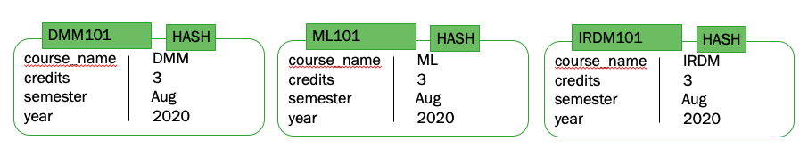

For student information, StudentID is used as a key. Student information including name, gender, and field of study are collected in a collection of key-value pairs of Redis HASH.

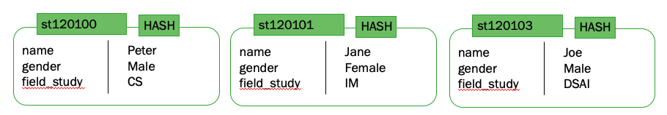

Registration information collect the selected courses of each student. In this case, we are going to use Redis SET to collect registration information. We design to use string “register:” concat with StudentID as a key. For example, we set “register:st120103” as a key for registration information of Mr. Joe. This Redis SET collects the unique string of CourseID.

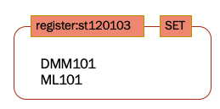

1. Write insert commands to store course information and student information in key-value store.

Solution:  
First of all, courses information and student information should be stored in the system, so admin collects this information by using the following commands.

* For course information, we use Redis Hash to collect the data.

> HMSET DMM101 course_name "DMM" credits 3 semester "Aug" year 2020

> HMSET ML101 course_name "ML" credits 3 semester "Aug" year 2020

> HMSET IRDM101 course_name "IRDM" credits 3 semester "Aug" year 2020

Using command HGETALL to get the courses information.

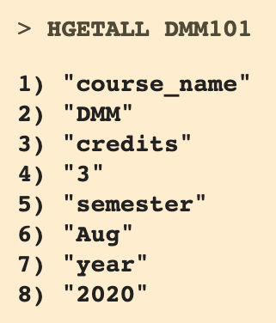 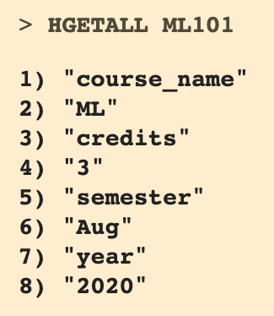 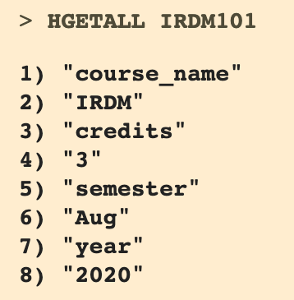

* For student information, we use Redis Hash to collect the data

> [HMSET st120100 name "Peter" gender "Male" field_study "CS"](http://try.redis.io/#run)

> [HMSET st120101 name "Jane" gender "Female" field_study "IM"](http://try.redis.io/#run)

> [HMSET st120103 name "Joe" gender "Male" field_study "DSAI"](http://try.redis.io/#run)

Using command HGETALL to get the student information.

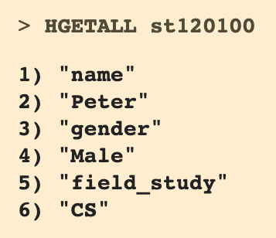 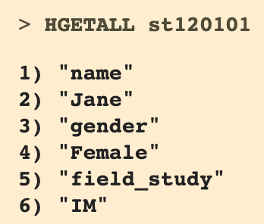 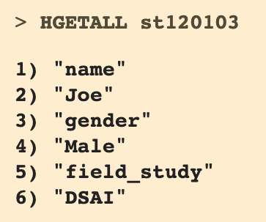

1. Write insert commands to collect the selected courses of Mr.Joe.

Solution:   
To collect register course of student, we use Redis SET to collect the selected course of Mr. Joe including course id of DMM and IRDM and set “register:st120103” as a key of this Redis SET.

> [SADD register:st120103 DMM101 IRDM101](http://try.redis.io/#run)

1. Write the command to retrive the selected courses of Mr.Joe .

Solution:

> SMEMBERS register:st120103

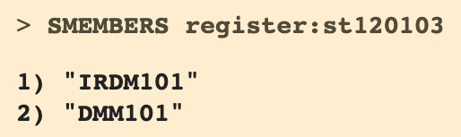

1. Write the command to drop course “IRDM101” and add course “ML101”.

Solution:

> SREM register:st120103 IRDM101

> [SADD register:st120103 ML101](http://try.redis.io/#run)

1. Write the command to retrive the all selected courses of Mr.Joe.

Solution:

> SMEMBERS register:st120103

